
AMERICAN INTERNATIONAL UNIVERSITY-BANGLADESH(AIUB)

FACULTY OF SCIENCE s TECHNOLOGY OBJECT ORIENTED PROGRAMMING - 2

Spring 2025-2026
Section: X PEOJECT REPORT ON
Online Course Management System
Supervised By
DR. MD. IFTEKHARUL MOBIN

Name | ID
Md. Arafat | 24-57174-2
Md. Rayhan | 24-60495-3
Syed Abdullah Al Noman | 24-57220-2
Monem Rakin Khan | 24-56450-1

CO2: Display and verify the mean of a real-life Project using the concepts of C# Graphical User Interface based environment with database integration to depict a desktop-based application.
Assessment Criteria | Not Attended/ Incorrect (0) | Inadequate (1-2) | Average (3) | Good (4) | Excellent (5)
Evaluation Criteria | Evaluation Definition |  |  |  | Total = 15
Requirement fulfillment | Properly demonstrate a real-life scenario-based project with proper functional requirement identification for the Object-Oriented Programming project development activities.
Validation | Ensuring the ability of students’ proper demonstration on validation forms in their system in terms of dealing with the data.
Verification | Identifying if the students can verify the system data along with proper functional requirements in terms of data flow.

CO3: Prepare and Explain a real life desktop based application synthesizing several component of C# along with development tools to adhere the given requirements.
Assessment Criteria | Not Attended/ Incorrect (0) | Inadequate (1-2) | Average (3) |  | Good (4) |  | Excellent (5)
Evaluation Criteria | Evaluation Definition
Organization of the application
Representation and Integration of Database
Graphical User Interface

CASE STUDY
In a modern online learning environment, students need a centralized platform to browse courses, enroll in programs, view assignments, and receive important notices.
Administrators require tools to manage courses, assignments, and announcements, while a super administrator oversees user accounts and system-wide settings.

The Online Course Management System addresses these needs by providing role-based access for three types of users: Students, Admins, and SuperAdmins. Students can view available courses, enroll after making a payment, track their enrolled courses, access assignments for those courses, read notices, and update their profile. Admins can create, update, and delete courses, assignments, and notices. SuperAdmins have full control including user management (adding, editing, deleting users and assigning roles).

Each course has a unique ID, title, description, instructor, and creation date. Assignments are linked to specific courses and include a deadline. Enrollments are recorded after successful payment, and notices are visible to all students. The system ensures data integrity through foreign key relationships and session management for logged-in users.

FUNCTIONALITIES
Student Module
- After login, student can view all available courses.
- Student can search/filter courses.
- Student can enroll in a course by making payment.
- Student can view enrolled courses.
- Student can view assignments.
- Student can view notices.
- Student can update profile.
- Student can logout.

Admin Module
- Admin can add, update, delete courses.
- Admin can manage assignments.
- Admin can manage notices.

SuperAdmin Module
- SuperAdmin can perform all admin functions.
- SuperAdmin can manage users.
- SuperAdmin can assign roles.

General
- Secure login system with role-based dashboard.
- Session management across forms.

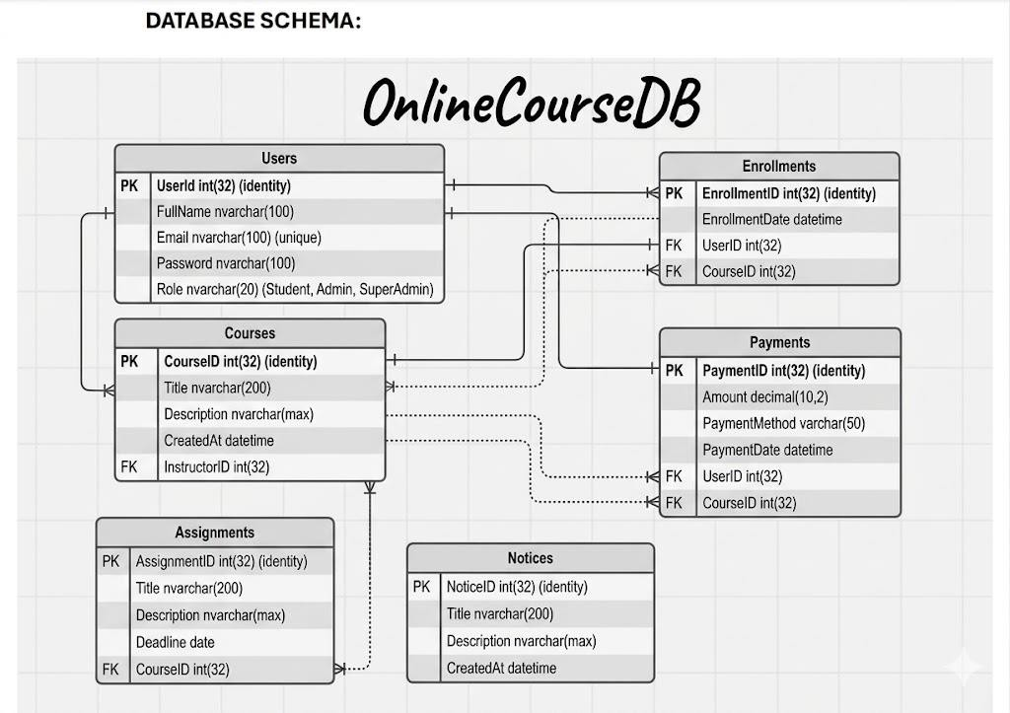
DATABASE SCHEMA

SQL QUERY:
CREATE DATABASE OnlineCourseDB; GO

USE OnlineCourseDB;

GO

-- Users Table
CREATE TABLE Users (
UserId INT PRIMARY KEY IDENTITY(1,1), FullName NVARCHAR(100) NOT NULL, Email NVARCHAR(100) UNIQUE NOT NULL, Password NVARCHAR(100) NOT NULL,
Role NVARCHAR(20) NOT NULL CHECK (Role IN ('Student', 'Admin', 'SuperAdmin'))

); GO

-- Courses Table
CREATE TABLE Courses (
CourseID INT PRIMARY KEY IDENTITY(1,1), Title NVARCHAR(200) NOT NULL,
Description NVARCHAR(MAX), InstructorID INT,
CreatedAt DATETIME DEFAULT GETDATE(),
FOREIGN KEY (InstructorID) REFERENCES Users(UserId)

); GO

-- Assignments Table
CREATE TABLE Assignments (
AssignmentID INT PRIMARY KEY IDENTITY(1,1), CourseID INT NOT NULL,
Title NVARCHAR(200) NOT NULL,
Description NVARCHAR(MAX), Deadline DATE,
FOREIGN KEY (CourseID) REFERENCES Courses(CourseID)

); GO

-- Notices Table
CREATE TABLE Notices (
NoticeID INT PRIMARY KEY IDENTITY(1,1),

Title NVARCHAR(200) NOT NULL,
Description NVARCHAR(MAX),
CreatedAt DATETIME DEFAULT GETDATE()
);

GO

-- Enrollments Table
CREATE TABLE Enrollments (
EnrollmentID INT PRIMARY KEY IDENTITY(1,1), UserID INT NOT NULL,
CourseID INT NOT NULL,
EnrollmentDate DATETIME DEFAULT GETDATE(), FOREIGN KEY (UserID) REFERENCES Users(UserId),
FOREIGN KEY (CourseID) REFERENCES Courses(CourseID)

); GO

-- Payments Table
CREATE TABLE Payments (
PaymentID INT PRIMARY KEY IDENTITY(1,1), UserID INT NOT NULL,
CourseID INT NOT NULL,
Amount DECIMAL(10,2) NOT NULL,
PaymentMethod VARCHAR(50) NOT NULL, PaymentDate DATETIME DEFAULT GETDATE(), FOREIGN KEY (UserID) REFERENCES Users(UserId),
FOREIGN KEY (CourseID) REFERENCES Courses(CourseID)

);GO

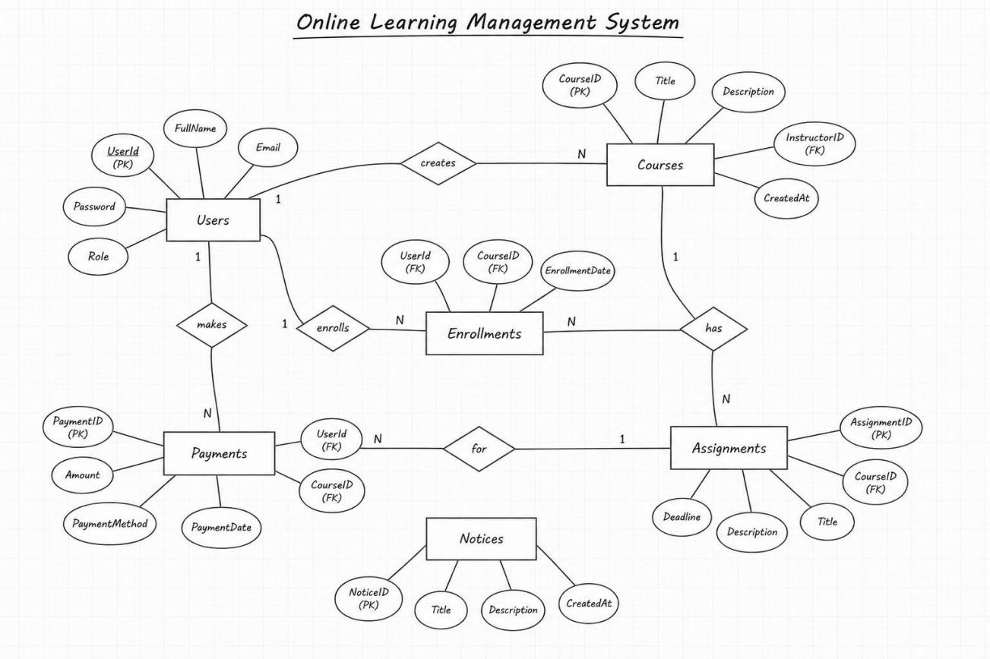
ER DIAGRAM

SCREENSHOTS WITH DESCRIPTIONS
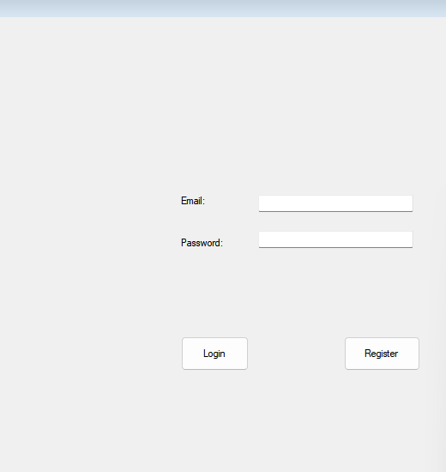
- Login Page

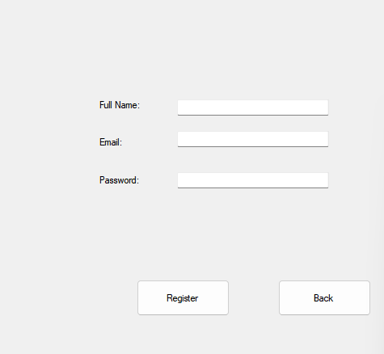
- Registration Page

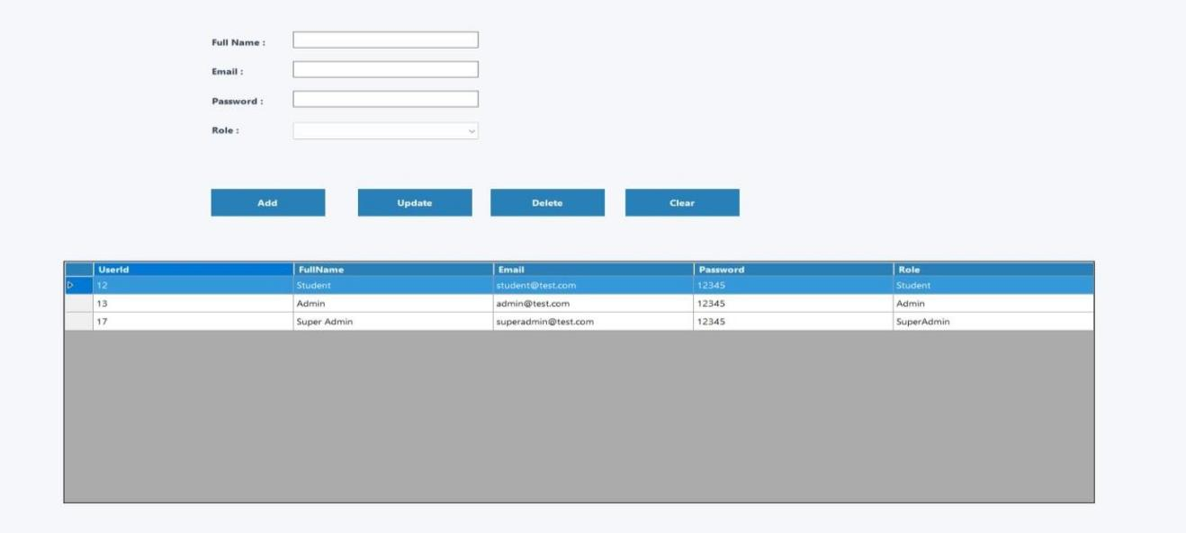
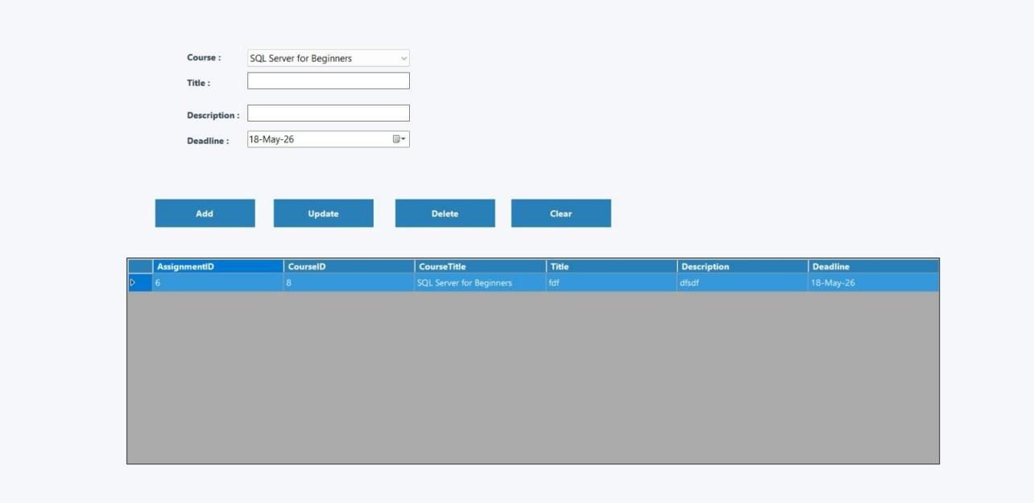
- Dashboards

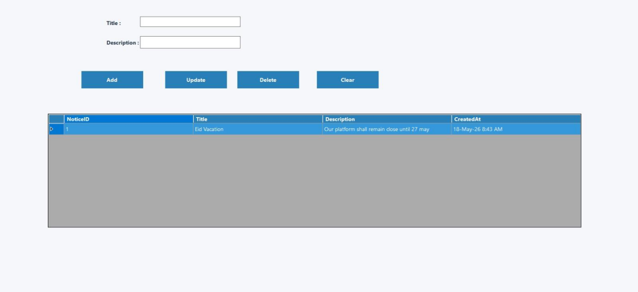

REFERENCES
- Microsoft Docs – Windows Forms Documentation
- Microsoft Docs – ADO.NET SqlConnection
- SQL Server Documentation – T-SQL Reference
- C# Programming Yellow Book by Rob Miles

